
Kingdom of Bahrain
Primary Healthcare Centers

Naraak
Phase 4: High-Fidelity Design System & Application Prototype

Prepared by
Fatima Yaser Darraj
Eman Yaser Alasaadi
Alya Hasan Aldaka
IT Trainees

Submitted to
AbdulRahim Mohamed Noor

26 August 2026

Document Control

Version History

Version | Date | Change Description
0.1 | 6 Aug 2026 | Initial Phase 4 template created with draft design system, and one worked high-fidelity mockup.
0.2 | 16 Aug 2026 | Design system finalized at spec level (color palette, typography, spacing, iconography, component checklist). Prototype interaction maps completed for all 12 services, built from the Phase 3 service flows. Component library and all 12 hi-fi screen sets remain to be built in Figma — this edition completes the written specification and token set, not the Figma file itself.
0.3 | 23 Aug 2026 | Design system and high-fidelity screens moved from spec-only to an actual built prototype in the Naraak app. Booking Appointments built end-to-end (in-center path); platform-level screens (Home, Appointments, Profile, All Services, Pending Requests) built; Medical Reports and Electronic Hajj Certificate partially built. Checklists and interaction maps updated to reflect built vs. outstanding work.
0.4 | 24 Aug 2026 | Removed Tele-Appointment as a standalone 12th service — it's a branch of Booking Appointments per Phase 3's 11-service count — and folded its interaction map into Section 4.1. Fixed the Vaccination Records and Medical Reports interaction maps to match Phase 3's decision points and the actual built screens.
0.5 | 25 Aug 2026 | Replaced Warning Amber (#C77B00) with Burnt Orange (#B45309) after a token-level contrast check found it below the WCAG 2.1 AA minimum. Added Section 6 (Accessibility & Bilingual Readiness) responding to the two areas raised in the Phase 3 sign-off by Mr. AbdulRahim AbdulJalil Mohamed.

Table of Contents
Document Control 2
Version History 2
1. Purpose of this Phase 4
2. Design System 4
2.1 Color Palette 4
2.2 Typography 5
2.3 Spacing & Grid 5
2.4 Iconography 5
2.5 Component Library Checklist 5
3. High-Fidelity Screens — What's Actually Built 6
3.1 Design System Reference Sheet 6
3.4 Medical Reports & Certificates — Partially Built 8
3.2 Platform-Level Screens (Sitemap, Section 2 of Phase 3) 9
3.3 Booking Appointments — In-Center Path Built End-to-End 11
3.5 Electronic Hajj Certificate — Partially Built 13
3.6 Screens Not Yet Started 13
4. Prototype Interaction Map 14
4.1 Booking Appointments (In-Center path built; Tele path spec-only) 14
4.2 Remaining Services 14
4.2.1 Vaccination Records & Certificate 14
4.2.2 Medical Reports & Certificates 15
4.2.3 Sehati Card Request for Newborns 15
4.2.4 Electronic Hajj Certificate (Partially built) 16
4.2.5 Update Residential Address 16
4.2.6 Health Fee Exemption Card Issuance 17
4.2.7 Request Mobile Unit Service 17
4.2.8 Mammogram Appointment Requests 17
4.2.9 Change Family Doctor 18
4.2.10 Primary Healthcare Research Applications 18
5. Prototype Screen Checklist by Service 18
6. Accessibility & Bilingual Readiness 19

1. Purpose of this Phase
Phase 4 turns the Phase 3 sitemap, service flows, and low-fidelity wireframes into an interactive, high-fidelity UI/UX design, underpinned by a cohesive design system.
This edition is built on:
- Phase 3 sitemap and navigation principles.
- Phase 3 service flows for all 11 in-scope services — each prototype interaction map in Section 4 is derived directly from its corresponding service flow. (Tele-Appointment is documented as a branch of Booking Appointments, consistent with Phase 3’s consolidated count of 11 services.)
- Phase 3 user-flow decision points — used to specify the error/empty-state screens each prototype must wire up.

2. Design System
These tokens are built on the color palette and typography proposed in the Phase 1/2 UI/UX Research document (Section 4). Finalized token values below are implemented directly in the built application (Section 3) as the single source of truth for developers.

2.1 Color Palette
Calm, trustworthy healthcare tones, with Bahrain's national red used only as a restrained, sparing accent (not a dominant color), consistent with the v0.1 design intent.
Swatch | Token | Hex | Usage
 | Primary Teal | #0F6B72 | Primary buttons, active nav state, key headers
 | Primary Dark | #0B4F54 | Pressed/hover states, high-emphasis text on light backgrounds
 | Secondary Ice | #EAF3F3 | Card backgrounds, section fills
 | Neutral Dark | #1F2D3D | Body text, icons
 | Neutral Gray | #5A6472 | Secondary text, captions, helper text
 | Success Green | #2E7D5B | Confirmed / Approved status badges
 | Burnt Orange | #B45309 | Pending / In Progress status badges
 | Bahrain Accent | #CE1126 | Critical errors only — e.g., failed booking, rejected request; never used decoratively
 | Background Default | #FFFFFF | Base screen background / canvas behind all content
Note: the original Warning Amber (#C77B00) measured 3.35:1 against white, below the WCAG 2.1 AA minimum of 4.5:1 for normal text. It was replaced with Burnt Orange (#B45309), which measures 5.02:1 and passes AA for both normal and large text.

2.2 Typography
Type family: Noto Sans, paired with Noto Sans Arabic for RTL screens — both are free, widely supported, and give full Latin + Arabic glyph coverage from the same design family, avoiding mismatched fallback fonts in bilingual layouts.
Style | Size | Weight | Usage
H1 / Page Title | 28–32px | Bold | Screen titles, e.g., 'Booking Appointments'
H2 / Section Header | 22–24px | Semi-Bold | Section labels, e.g., 'Available Slots'
H3 / Card Title | 18–19px | Semi-Bold | Card headings, e.g., doctor name
Body | 15–16px | Regular | Descriptions, form labels
Caption / Secondary | 13–14px | Regular | Timestamps, helper text, nav labels
Button Label | 15–16px | Semi-Bold | All call-to-action buttons

2.3 Spacing & Grid
- Base spacing unit: 8px, with common increments of 8 / 16 / 24 / 32px for padding and margins.
- Card corner radius: 16–18px (rounded, approachable, consistent with the worked mockup).
- Mobile layout: single-column, 16–20px screen padding; Web layout: 12-column grid with max content width, per standard responsive practice.

2.4 Iconography
- Single consistent outline icon set across mobile and web (e.g., Phosphor or Feather — both ship RTL-safe directional variants).
- Color-filled icons reserved for primary actions only, to avoid visual noise across the 11-service scope.
- RTL-mirrored versions provided for all directional icons (back arrows, chevrons), matching the Phase 3 RTL principle.

2.5 Component Library Checklist
Variants below are specified in Section 2.1–2.4; status is now measured against the actual built application (Section 3).
Component | Variants Needed | Status
Buttons | Primary / Secondary / Disabled / Loading | Built — Primary, Secondary, and Disabled shown in Figure 1 and used throughout the app; Loading state not yet built.
Input fields | Default / Focused / Error / Disabled | Built — Default, Focused, and Error states shown in Figure 1 (search field, email field, CPR field); Disabled state not yet built.
Cards | List item / Summary / Status | Built — all three variants are in active use: appointment list items, Family Doctor / Pending Requests summary cards, and status-badged cards.
Navigation bar | Mobile bottom nav / Web top nav, active & inactive states | Built — both present on every delivered screen (Section 3), with clear active/inactive styling.
Status badges | Pending / Approved / Rejected / In Progress | Built — Approved, Processing, Under Review, Action Needed, and Completed are all in use, which exceeds the original 4-state spec.
Modals / Dialogs | Confirmation / Error / Consent | Pending — no built screen yet uses an overlay modal; booking confirmation is currently a full-screen step instead of a dialog.
Form controls | Dropdown / Date picker / File upload / Checkbox | Partial — category dropdown and a searchable consultant list are built (Figure 15); date picker, file upload, and checkbox are not yet built.
Empty states | No results / No data / Offline | Partial — “No Available Slots” is built (Figure 14); “No data” and “Offline” variants are not yet built.
Notification / Toast | Success / Error / Info | Pending — only a notification-bell badge count is built; there is no in-app toast/snackbar yet.
Summary: 5 of 9 components are now built and visually confirmed against the running application; 2 are partially built; 2 remain pending and will be executed in the Flutter phase (Modals/Dialogs and Notification/Toast).

3. High-Fidelity Screens — What's Actually Built
This section replaces the single worked mockup from previous versions with the actual high-fidelity screens now built in the Naraak web and mobile application, showcased in Figma. Minor UI refinements — spacing, wording, icon choices, and token-level color adjustments — may still be applied as the remaining services are built and accessibility checks are completed. These affect presentation only; the Phase 3 information architecture and flows remain unchanged.

3.1 Design System Reference Sheet
The finalized tokens from Section 2 are compiled into a single reference sheet, used as the source of truth for both the web and mobile builds.
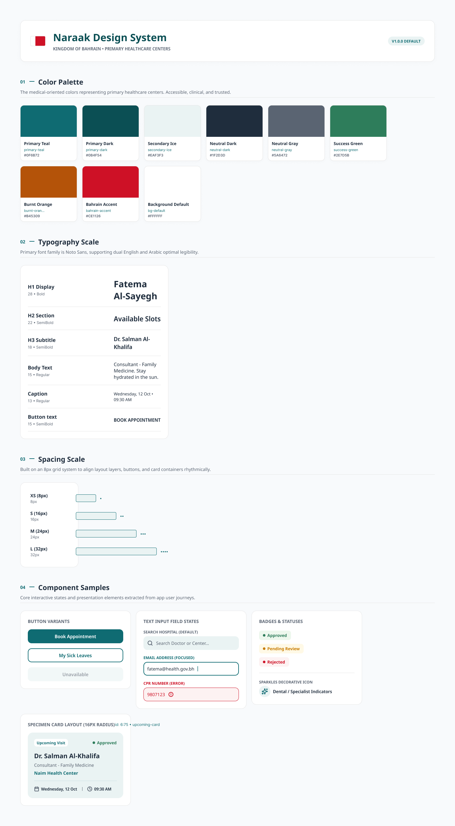
Figure 1: Naraak Design System reference sheet — color palette, typography scale, spacing scale, and component samples as implemented.

3.4 Medical Reports & Certificates — Partially Built
Only the first step of the three-step request flow (Details → Review → Confirm) is built so far, but it already demonstrates the category-first, doctor-history-only design called for in Phase 3 Section 3.2.

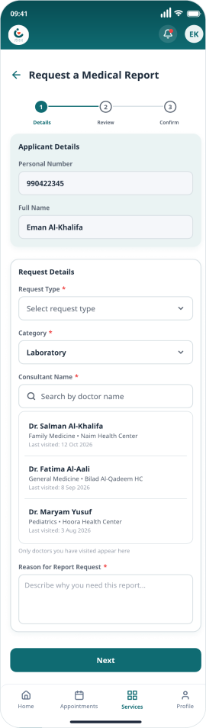
Figure 15: Request a Medical Report — Step 1 of 3 (Details): category, searchable consultant list limited to doctors the patient has actually visited, and reason field.

3.2 Platform-Level Screens (Sitemap, Section 2 of Phase 3)
The primary navigation destinations from the Phase 3 sitemap are built and demonstrable on real data (dummy/demo accounts):
- Home Dashboard — built for web (Figure 2) and mobile (Figure 5).
- Appointments / My Appointments — built for web (Figure 3) and mobile (Figure 8).
- All Services — built for mobile only so far (Figure 6); a web equivalent is not yet built.
- Profile & Settings — built for web (Figure 4) and mobile (Figure 7).
- Pending Requests — built for mobile only so far (Figure 9), reached from the Home dashboard’s “Pending Requests” card.

3.2.1 Web screens:
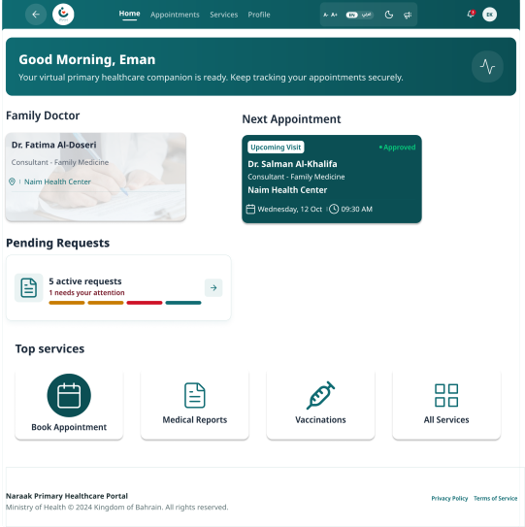 | 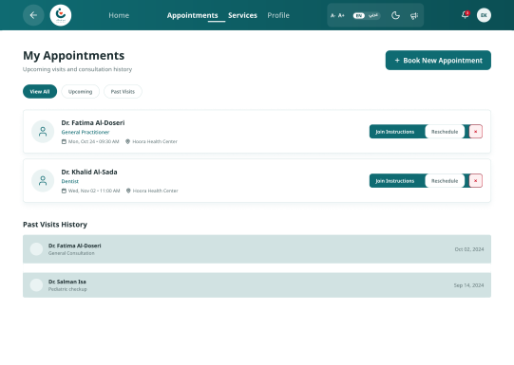 | 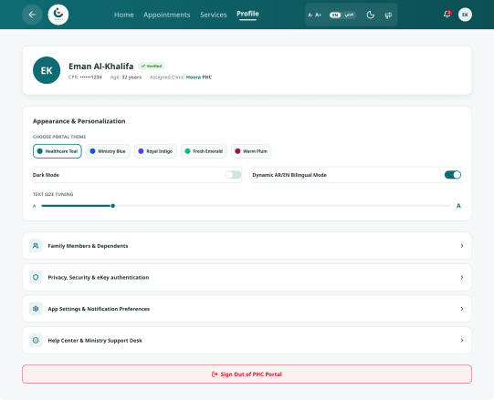
Figure 2: Home Dashboard (web) | Figure 3: Appointments (web) | Figure 4: Profile & Settings (web)

3.2.2 Mobile screens:
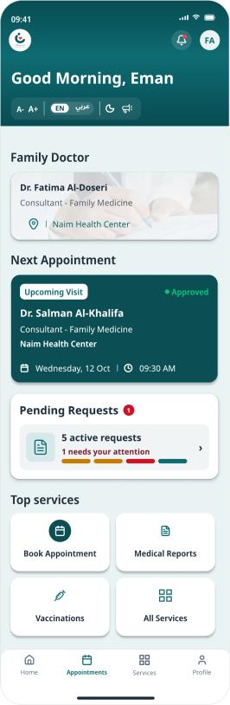 | 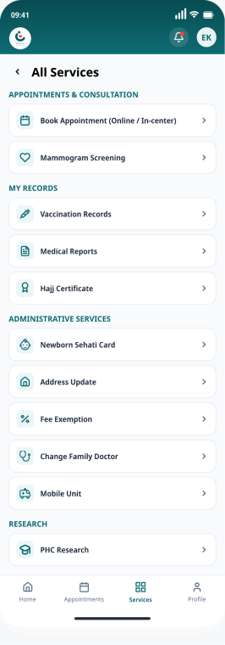 | 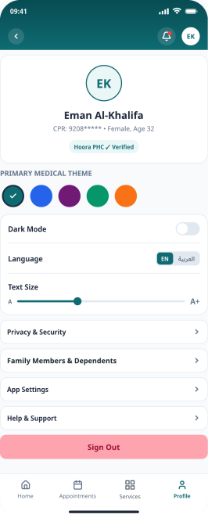
Figure 5: Home Dashboard (mobile) | Figure 6: All Services (mobile) | Figure 7: Profile & Settings (mobile)

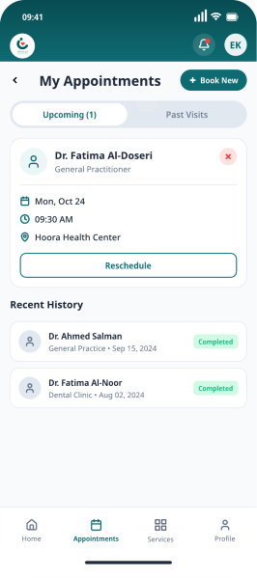 | 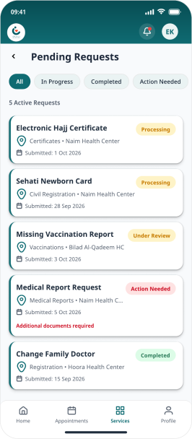
Figure 8: My Appointments (mobile) | Figure 9: Pending Requests (mobile)

3.3 Booking Appointments — In-Center Path Built End-to-End
Booking Appointments' in-center path is the one fully built end-to-end on mobile, matching the flow specified in Section 4.1. The tele-appointment branch of this same service (instructions, join link, and in-call screens — see Section 4.1) has not been built yet and remains at the written-specification stage; it is tracked as outstanding work within Booking Appointments, not as a separate service (see the “Note on service count” in Phase 3, Section 2).
Step | Screen | Figure
1 | Book Appointment — entry point (choose by date & doctor, closest appointment, or available slots) | Figure 10
2 | Available Slots — results list (3 slots found across the Capital Governorate) | Figure 11
3 | Booking Review — confirms doctor, center, address, date/time, and patient details | Figure 12
4 | Booking Confirmed — appointment pass with status, center, date/time, CPR, and booking ID | Figure 13
5 | No Available Slots — empty-state alternate path when filters return nothing | Figure 14

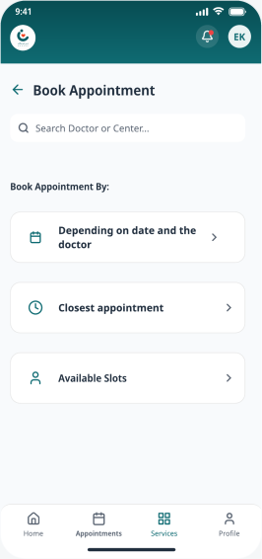 | 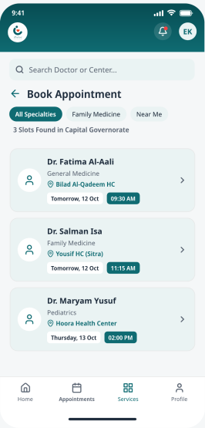 | 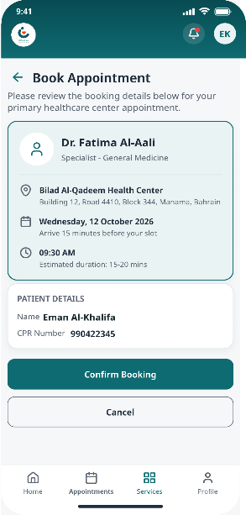
Figure 10: Book Appointment (entry) | Figure 11: Available Slots | Figure 12: Booking Review

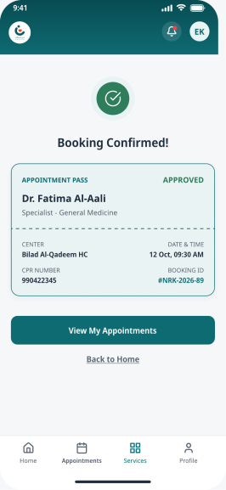 | 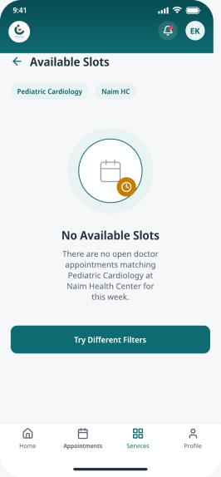
Figure 13: Booking Confirmed | Figure 14: No Available Slots (empty state)

3.5 Electronic Hajj Certificate — Partially Built
Only the Status Tracker screen is built, and it already demonstrates the exact fix Phase 3 and Phase 5 called for: the prerequisite is stated up front, and the "Processing" stage is shown with a plain-language 4-step progress tracker (Requested → Processing → Ready → Downloaded) instead of the old generic "Not Found" failure state.
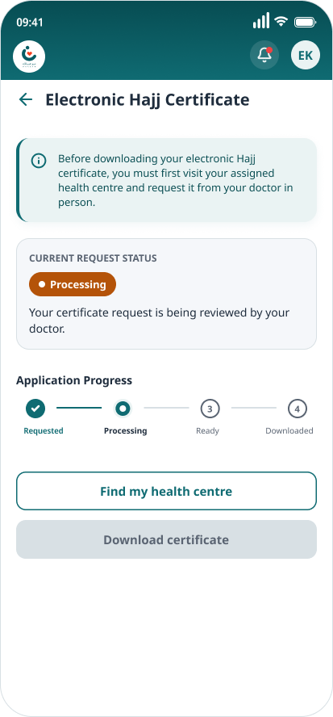
Figure 16: Electronic Hajj Certificate — Status Tracker (Processing state).

3.6 Screens Not Yet Started
The remaining 8 services have no built screens yet and remain at the Section 4.2 specification stage only: Vaccination Records & Certificate, Sehati Card Request for Newborns, Update Residential Address, Health Fee Exemption Card Issuance, Request Mobile Unit Service, Mammogram Appointment Requests, Change Family Doctor, and Primary Healthcare Research Applications. In addition, the tele-appointment branch of Booking Appointments (Section 3.3) also has no built screens yet and will be implemented in the Flutter prototype phase.
Note on delivered screen scope: The high-fidelity screens delivered in this phase — the platform-level screens (Home Dashboard, All Services, Profile & Settings, My Appointments, Pending Requests), the Booking Appointments in-center flow, and the two partially built service screens — were approved by Mr. Mohamed Ateya Neama. He confirmed that this number of screens is sufficient to demonstrate the design system and satisfy the Phase 4 documentation requirement, and that the remaining service screens are to be produced during Phase 6 (Flutter prototype) rather than as additional Figma deliverables in this phase.

4. Prototype Interaction Map
Beyond static screens, screen-to-screen navigation should simulate the real app. Each map below is derived directly from the Phase 3 service flow, with one alternate/error transition drawn from its Phase 3 decision points. Status callouts reflect what is actually built in the application (Section 3) versus still spec-only.

4.1 Booking Appointments (In-Center path built; Tele path spec-only)
From Screen | Trigger | To Screen | Transition
Home / Dashboard | Tap 'Booking Appointments' | Results List | Slide in from right
Results List | Tap a slot card | Slot Confirmation | Slide in from right
Slot Confirmation | Tap 'Confirm' | Booking Success | Fade / overlay
Booking Success | Tap 'View My Appointments' | My Appointments List | Slide in from right
Results List | No slots match filter | Empty State overlay | Fade in place

4.1.1 Tele-appointment branch:
From Screen | Trigger | To Screen | Transition
Booking entry | Chooses ‘Tele’ instead of ‘In-center’ | Tele Instructions Screen | Slide in from right
Tele Instructions Screen | Reviews a short visual guide | Simplified Visual Guide | Slide in from right
Simplified Visual Guide | Joins the consultation via the link | Join Button / Resend Option | Slide in from right
Join Button / Resend Option | Completes the video consultation | In-Call / Video Screen | Fade / overlay
In-Call / Video Screen | Receives a post-consultation summary and instructions | Notification | Slide in from right
Simplified Visual Guide | Alternate: was the original join-link notification missed? | Empty / Error State overlay | Fade in place

4.2 Remaining Services

4.2.1 Vaccination Records & Certificate
From Screen | Trigger | To Screen | Transition
Home > Vaccination Records | Views full history; missing records are flagged | Vaccination History List | Slide in from right
Vaccination History List | Selects a certificate to download | Download (PDF, no form) | Fade / overlay
Vaccination History List | Selects ‘Report Missing Vaccination’ | Upload Form | Slide in from right
Upload Form | Submits name, personal number (auto-fill), uploaded document, and comments | Confirmation Screen | Fade / overlay
Confirmation Screen | Checks status of a submitted missing-record report | Status Tracker | Slide in from right
Upload Form | Alternate: is the uploaded file a valid type/size? | Empty / Error State overlay | Fade in place

4.2.2 Medical Reports & Certificates
From Screen | Trigger | To Screen | Transition
Home > Medical Reports & Certificates | Chooses ‘View reports’ | All PHC Reports List | Slide in from right
All PHC Reports List | Taps any report | Download Screen | Fade / overlay
Home > Medical Reports & Certificates | Chooses ‘Request a report’ | Category Selector | Slide in from right
Category Selector | Selects the consultant from a searchable dropdown of doctors seen | Searchable Consultant Dropdown | Slide in from right
Searchable Consultant Dropdown | Enters reason and contact details, taps Review | Review Screen | Slide in from right
Review Screen | Confirms and submits the report request | Confirmation Screen (tracked in Pending Requests) | Fade / overlay
Confirmation Screen | Receives a notification when the requested report is ready | Notification → Download Screen | Slide in from right
Category Selector | Alternate: is the result already available for direct download? | Empty / Error State overlay | Fade in place

4.2.3 Sehati Card Request for Newborns
From Screen | Trigger | To Screen | Transition
Family > Newborn Sehati Card | Sees newborn | Pre-filled Request Form | Slide in from right
Pre-filled Request Form | Confirms contact details and residential block | Short Confirmation Step | Slide in from right
Short Confirmation Step | Sees a 'Request Submitted' status immediately after submitting | Status Screen | Fade / overlay
Status Screen | Is notified once the card has been issued | Push/SMS Notification | Slide in from right
Pre-filled Request Form | Alternate: can the newborn's CPR be matched with the birth registry? | Empty / Error State overlay | Fade in place

4.2.4 Electronic Hajj Certificate (Partially built)
From Screen | Trigger | To Screen | Transition
Services > Electronic Hajj Certificate | If eligible | Service Info Screen | Slide in from right
Service Info Screen | Tracks certificate generation progress | Status Tracker | Slide in from right
Status Tracker | Downloads the certificate with its verified QR code | Download / Print Screen | Fade / overlay
Download / Print Screen | Receives confirmation the certificate is ready to travel with | Notification | Slide in from right
Service Info Screen | Alternate: has the in-person doctor-visit prerequisite been completed? | Empty / Error State overlay | Fade in place

4.2.5 Update Residential Address
From Screen | Trigger | To Screen | Transition
Profile > Update Address | Enters the new residential block; previous block and CPR are known | Address Update Form | Slide in from right
Address Update Form | Confirms and submits the address update | Consent Checkbox & Submit | Slide in from right
Consent Checkbox & Submit | Sees the newly assigned PHC center named on screen immediately | Confirmation Screen | Fade / overlay
Confirmation Screen | Receives a notification and sees the update reflected in profile | Updated Profile Card | Slide in from right
Address Update Form | Alternate: does the new address fall under a different PHC catchment? | Empty / Error State overlay | Fade in place

4.2.6 Health Fee Exemption Card Issuance
From Screen | Trigger | To Screen | Transition
Home > Fee Exemption Card | Sees an upfront checklist of required documents before starting | Upfront Checklist Screen | Slide in from right
Upfront Checklist Screen | Completes the application across a few short steps instead of one | Multi-Step Form | Slide in from right
Multi-Step Form | Submits the application with validated document uploads | Submission Screen | Fade / overlay
Submission Screen | Tracks the exemption request's status after submission | Status Tracker | Slide in from right
Upfront Checklist Screen | Alternate: are all checklist documents attached before proceeding? | Empty / Error State overlay | Fade in place

4.2.7 Request Mobile Unit Service
From Screen | Trigger | To Screen | Transition
Home > Mobile Unit Request | Enters patient information | Request Form | Slide in from right
Request Form | Provides the reason for the home-visit request | Free-Text Reason Field | Slide in from right
Free-Text Reason Field | Submits the request | Confirmation Screen | Fade / overlay
Confirmation Screen | Receives a notification once the visit is scheduled | Notification | Slide in from right
Request Form | Alternate: is the requester submitting on behalf of a verified family member? | Empty / Error State overlay | Fade in place

4.2.8 Mammogram Appointment Requests
From Screen | Trigger | To Screen | Transition
Women's Health > Mammogram Request | Proceeds once age-eligibility and last-screening date are checked | Eligibility Check Screen | Slide in from right
Eligibility Check Screen | Confirms contact details and submits the request | Confirmation Step | Slide in from right
Confirmation Step | Receives on-screen confirmation that the request was submitted | Confirmation Screen | Fade / overlay
Confirmation Screen | Is notified once the mammogram appointment is scheduled | Notification | Slide in from right
Eligibility Check Screen | Alternate: does the patient meet the age/last-screening eligibility? | Empty / Error State overlay | Fade in place

4.2.9 Change Family Doctor
From Screen | Trigger | To Screen | Transition
Profile > Change Family Doctor | Browses available family doctors at their health center | Doctor Browse / Capacity View | Slide in from right
Doctor Browse / Capacity View | Selects a preferred doctor | Request Form | Slide in from right
Request Form | The system automatically verifies the chosen doctor has quota | Confirmation Screen | Fade / overlay
Confirmation Screen | Is notified once the reassignment is approved | Notification | Slide in from right
Doctor Browse / Capacity View | Alternate: does the selected doctor have available quota? | Empty / Error State overlay | Fade in place

4.2.10 Primary Healthcare Research Applications
From Screen | Trigger | To Screen | Transition
Researcher / Student Entry Point | Selects applicant type: Student | Type Selector | Slide in from right
Type Selector | Uploads required supporting documents | Upload Form | Slide in from right
Upload Form | Submits the proposal with supervisor and research details | Submission Screen | Fade / overlay
Submission Screen | Is notified of the review outcome | Notification | Slide in from right
Type Selector | Alternate: does an uploaded document meet the stated type/size? | Empty / Error State overlay | Fade in place

5. Prototype Screen Checklist by Service
Screen counts have been revised from the Phase 3 Wireframe Checklist. The Phase 3 low-fidelity pass identified 40 screens in total (29 service screens plus 11 platform-level screens); at high fidelity, several services required additional review, confirmation, and error-state screens, bringing the service-screen count to 50. Status is measured against the actual built application (Section 3) rather than Figma. As with Phase 3, the total number of screens remains subject to change; additional screens may be identified as the remaining services are built out.
Service | Screens | Designed (Hi-Fi) | Prototype Links Wired | Reviewed
Booking Appointments | 5 | Built (mobile, in-center path — Figures 10–14); tele branch not started | Wired & demoed end-to-end (in-center path) | Internal draft
Vaccination Records & Certificate | 5 | Not started | Not started | Pending
Medical Reports & Certificates | 5 | Partial (1 of 5 — Figure 15) | Not yet | Pending
Sehati Card Request for Newborns | 4 | Not started | Not started | Pending
Electronic Hajj Certificate | 5 | Partial (1 of 5 — Figure 16) | Not yet | Pending
Update Residential Address | 4 | Not started | Not started | Pending
Health Fee Exemption Card Issuance | 5 | Not started | Not started | Pending
Request Mobile Unit Service | 4 | Not started | Not started | Pending
Mammogram Appointment Requests | 4 | Not started | Not started | Pending
Change Family Doctor | 5 | Not started | Not started | Pending
Primary Healthcare Research Applications | 4 | Not started | Not started | Pending
Note: platform-level screens (Home, All Services, Profile & Settings, My Appointments, Pending Requests) sit outside the 11-service count above; they are built in the mobile app, and Home / Appointments / Profile are additionally built in the responsive web app (Section 3.2).

6. Accessibility & Bilingual Readiness
Following the Phase 3 sign-off, the supervisors identified two areas to carry into Phase 4. Both are addressed at the design-system level in this phase and will be verified against the rendered screens as the remaining services are built.
- RTL mirroring and typography readiness. The type family selected in Section 2.2 (Noto Sans, paired with Noto Sans Arabic) provides full Latin and Arabic glyph coverage from a single design family, avoiding mismatched fallback fonts in bilingual layouts. The icon set specified in Section 2.4 ships RTL-safe directional variants, and all directional icons (back arrows, chevrons) are mirrored per the Phase 3 RTL principle. An Arabic (RTL) variant of the Home Dashboard has been produced to validate that the layout, typography scale, and component spacing mirror correctly; the remaining screens will follow the same pattern as they are built.
- WCAG 2.1 AA compliance. A token-level contrast check has been completed against the Section 2.1 palette; every pairing now meets the 4.5:1 minimum for normal text, following the replacement of Warning Amber documented in that section. Status states are also distinguished by color and label (Approved, Processing, Under Review, Action Needed, Completed) so that color is never the only signal. A full check against the rendered screens, and measurement of tap targets against the 44×44px minimum, remain outstanding and are scheduled before the Phase 6 build is finalized.

